Purpose:

This document helps to understand the folder structure used in Schneider. With these standards, we can maintain a common folder structure across the project. Please note that this document covers only the Operational Data Store and Schneider Extended Analytics projects.

Schneider Extended Analytics:

There are currently 2 defined layers
- Acquisition
- Warehouse

Acquisition:
This is a folder for PSA tables and the corresponding initial load processes.
- Main folder should be created for incremental load.
- Sub Folder should be created under main folder for Initial load processes.

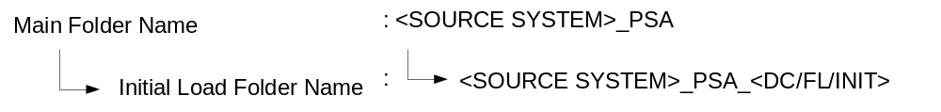

Warehouse:
This is a folder for Warehouse tables (Facts and Dimensions) and the corresponding initial load processes.
- Main folder should be created for incremental Fact/Dim load.
- Sub Folder should be created under main folder for Initial load processes.

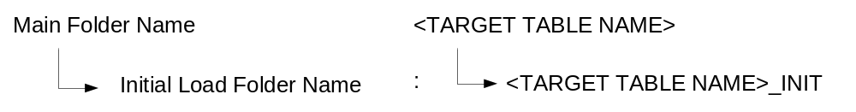

\

Operational Data Store:

There are currently 3 defined layers in OP
- Acquisition,
- Architected,
- RTA (Real-Time Analytics).

Acquisition:
This is a folder for the tables (ODS) which are being loaded from operational tables and the corresponding initial load/Staging table processes.
- Main folder should be created for ODS table load.
- Sub Folder should to be created under main folder for Initial load processes/Staging loads.

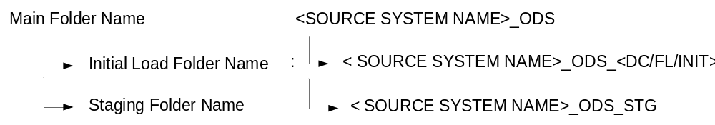

Architected:
This is a folder for XO tables which are being loaded from ODS tables, to load common attributes from different tables and the corresponding initial load/Staging table processes.
- Main folder should be created for XO table load.
- Sub Folder should to be created under main folder for Initial load processes/Staging loads.

RTA:
This is a folder for Real time Analytics tables which are being loaded from analytical table for operational report usage. Sub Folder needs to be created under main folder for Initial load processes.

